Procedure I ‐ DNA Fragment Size
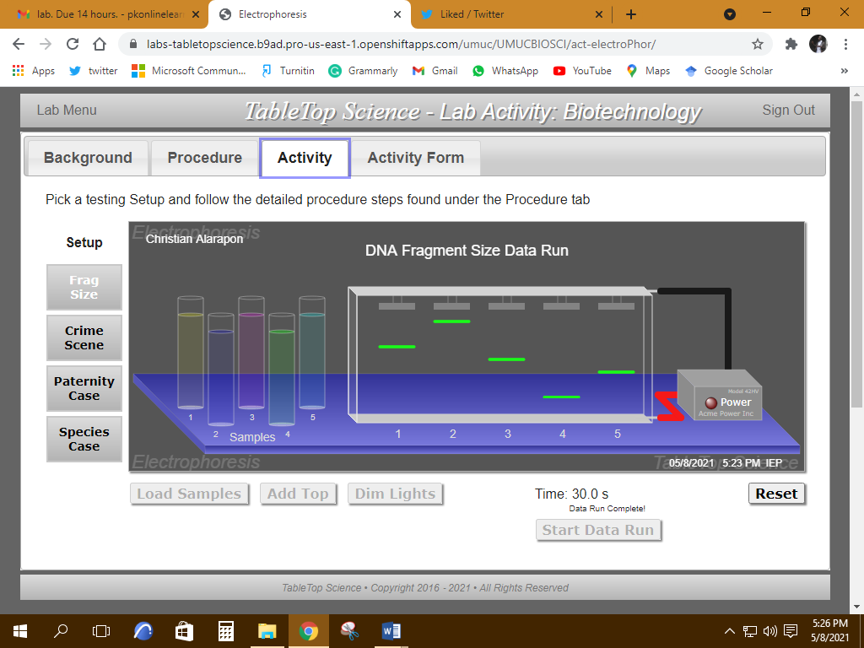

Procedure II ‐ Crime Scene DNA
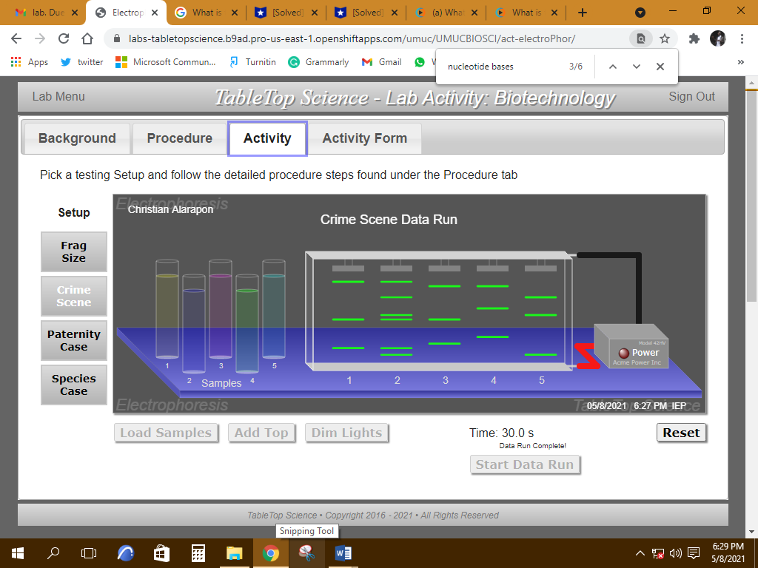

Procedure III ‐ Paternity Case

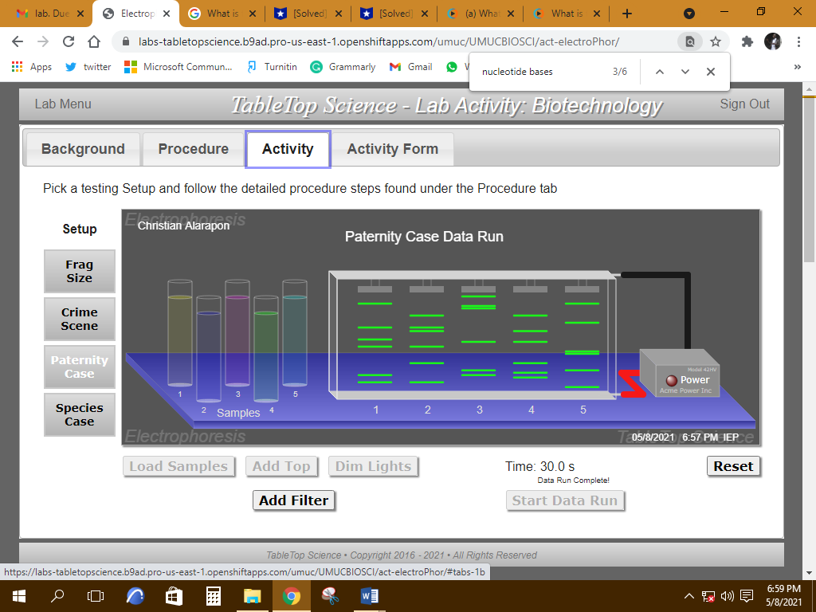

Procedure III ‐ Paternity Case (with filters)
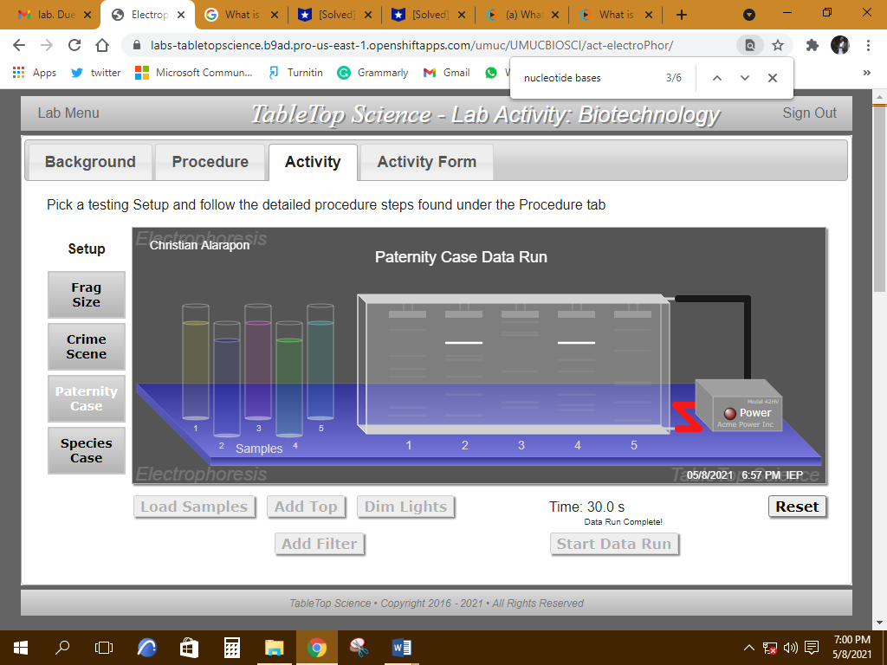

Procedure IV ‐ Species DNA Comparison
